You can get this document on tape, in Braille, large print and various computer formats if you ask us. Please contact Interpretation and Translation Service (ITS) on 0131 242 8181 and quote reference number 23-8523 ITS can also give information on community language translations.

Reference number: 23-8523

Self-Directed Support Contracts Review

We are doing a review of Self-Directed Support Options, especially Direct Payments. We need to hear from people who have used or helped someone to use any of the services listed below.

Your feedback would help us to understand how the services allow people to have choice and control in the life they want. It will help us find out what is working well and what needs to be done better.

Please give us your views
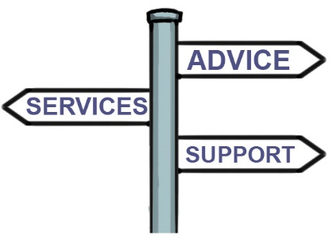

1. Have you used any of the services below?
(Please tick all that apply)

Lothian Centre for Inclusive Living (LCiL)

Independent support service
Grapevine Service
Payroll / Financial Management Service

Fife Business Services

Payroll / Financial Management Services

Accountability

Payroll / Financial Management Services

- How did you hear about the service/s you used?
A medical professional
A Council worker
A support worker
The internet
An organisation
Family member or friend
Other (please write your answer in the box below)

- What has changed for you because of using the services? (Please write your answer in the box below)

- Overall, how happy or unhappy are you with the service provided?

Very happy
Quite happy
Neither happy nor unhappy
Quite unhappy
Very unhappy

- Is there anything you would like to tell us about the service? (Please write your answer in the box below)

- Do you think you had choice and control over your decision to use a payroll organisation?
(Please tick one answer only)
Yes
No
Don’t know

Please tell us your reasons for your answer above using the box below.

Support from others

We value the views of anyone who has supported you in accessing the above service. Please show them this section so they can give their comments.

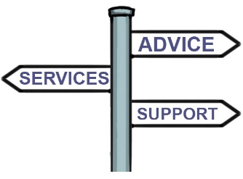
- Please tell us which service you have supported someone to access (Please tick all that apply)

Lothian Centre for Inclusive Living (LCiL)

Independent support service
Grapevine Service
Payroll / Financial Management Service

Fife Business Services

Payroll / Financial Management Services

Accountability

Payroll / Financial Management Services

- Please add any comments about the service in the box below.

You can complete this questionnaire online by going to:
https://consultationhub.edinburgh.gov.uk/hsc/b8207990

Please respond by 10th July 2023

Thank you for taking the time to complete this survey.

